**1.Introduction:**

**1.1 OverView:**

Create a CRM Application which helps the applicant to track the No. of jobs he applied and helps him to find the job posted by the various recruiters, find the best attributes to be involved to run the process in a smooth way and easily to track.

**1.2 Purpose :**

Purpose of the application is to develop a job tracking for the applicants based on their job profiles from various recruiters.

**2.Problem Definition and Design Thinking**

**2.1 Empathy map**

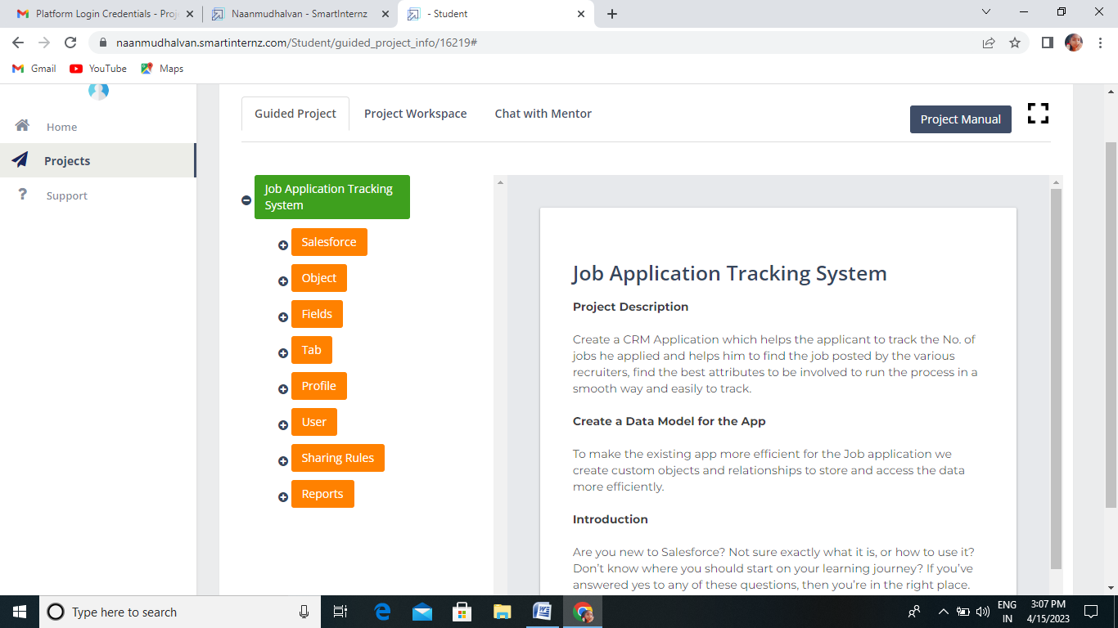

**2.2 Ideation &Brainstoring map**

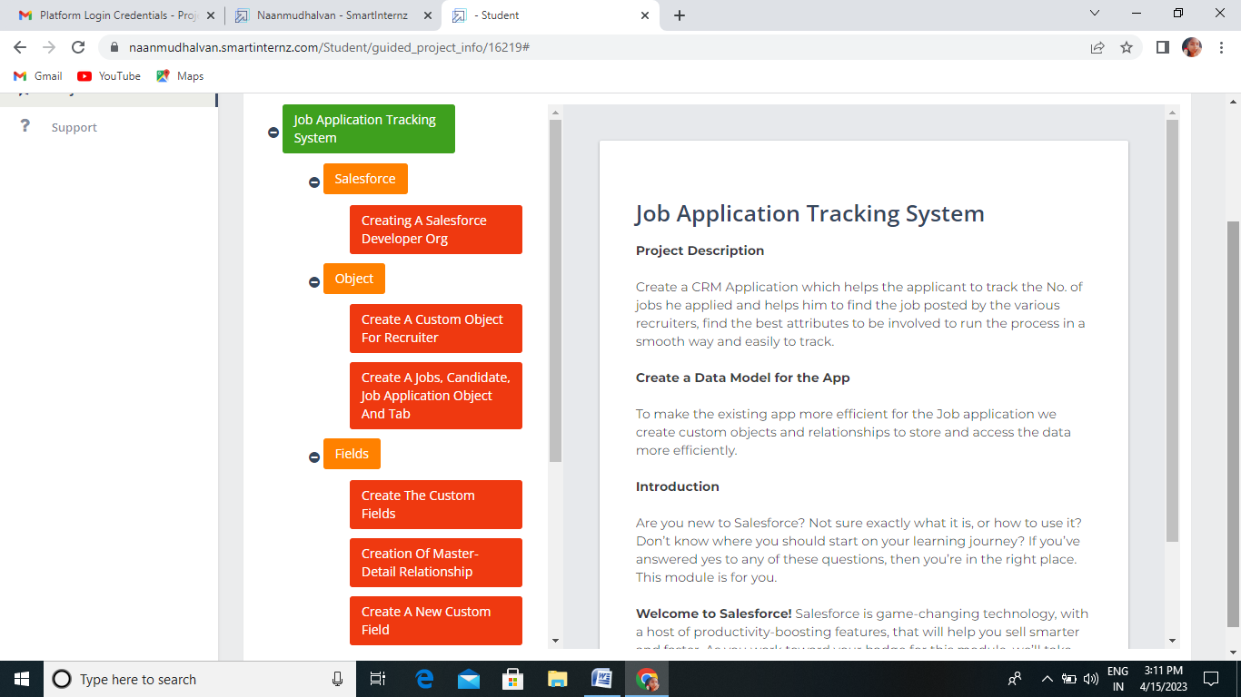

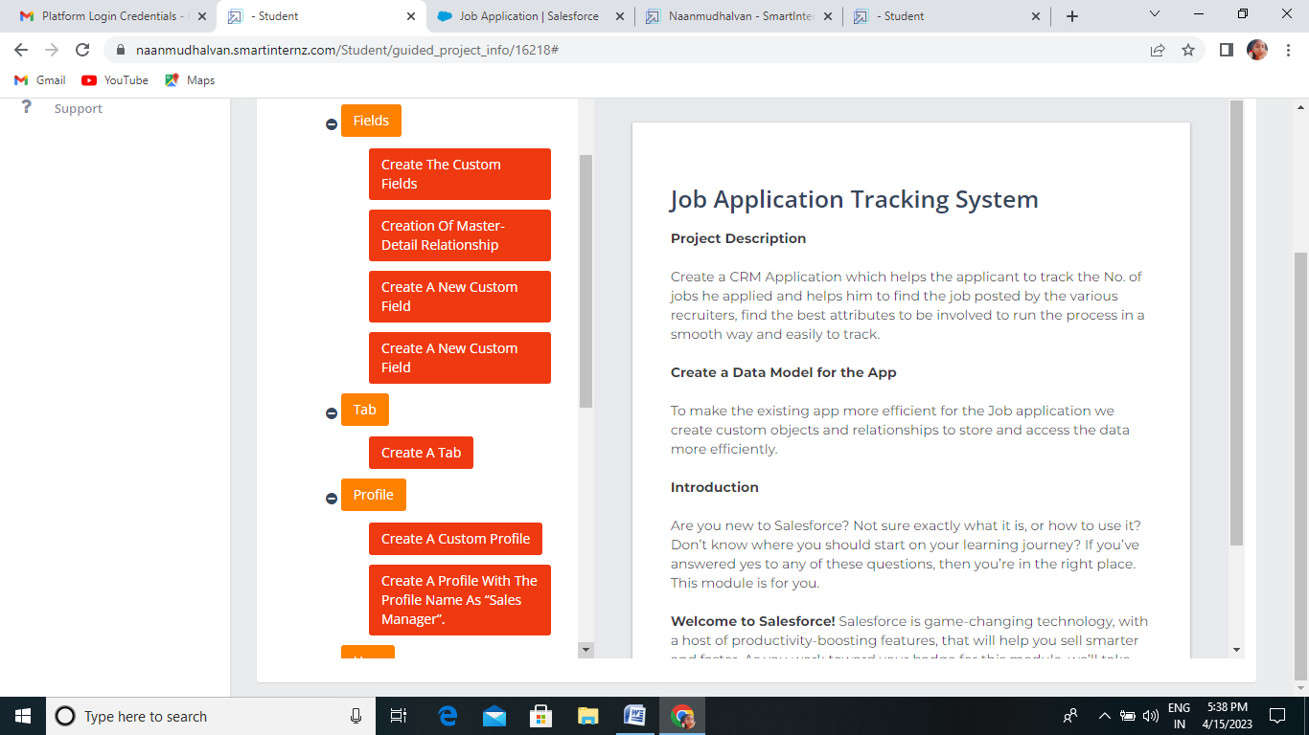

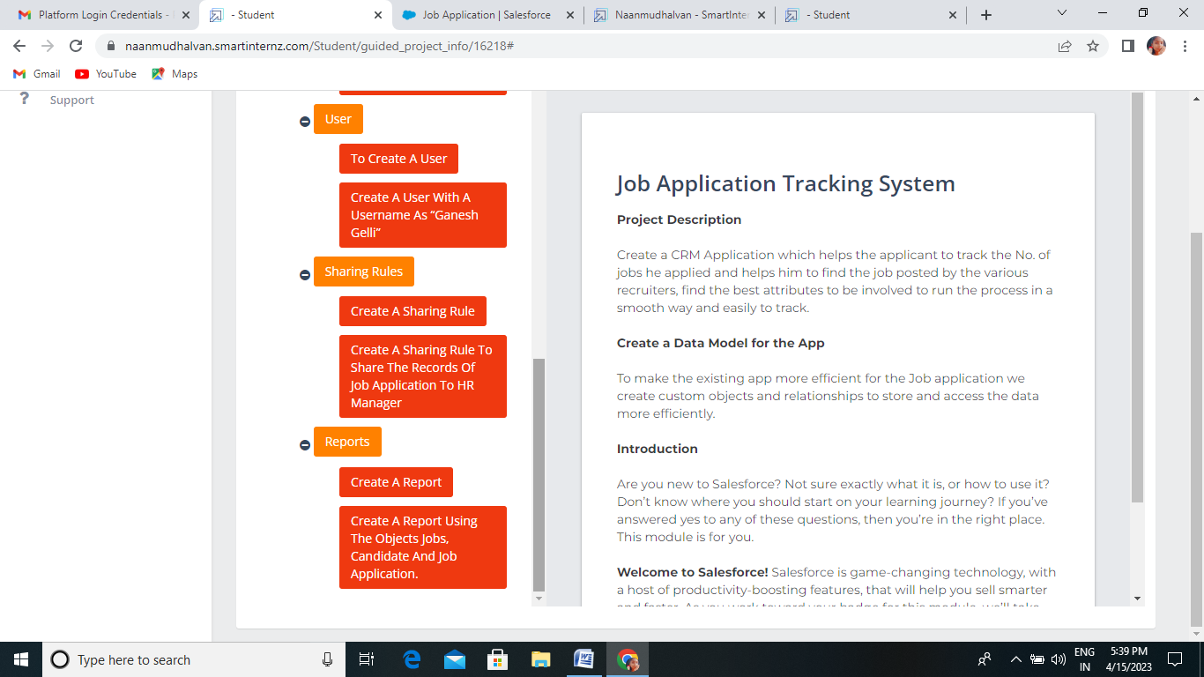

**3.1.DataModel**

|  |  |  |
| --- | --- | --- |
| **OBJECT NAME** | **FIELD NAME** |  |
|  | **FIELD LABEL** | **DATA TYPE** |
| **RECRUITER** | |  | | --- | | [Recruiter Number](https://governmentartsandscienc435-dev-ed.develop.lightning.force.com/lightning/setup/ObjectManager/01I2w000003Rw0T/FieldsAndRelationships/Name/view) | | [Owner](https://governmentartsandscienc435-dev-ed.develop.lightning.force.com/lightning/setup/ObjectManager/01I2w000003Rw0T/FieldsAndRelationships/Owner/view) | | [Last Modified By](https://governmentartsandscienc435-dev-ed.develop.lightning.force.com/lightning/setup/ObjectManager/01I2w000003Rw0T/FieldsAndRelationships/LastModifiedBy/view) | | [Job tittle](https://governmentartsandscienc435-dev-ed.develop.lightning.force.com/lightning/setup/ObjectManager/01I2w000003Rw0T/FieldsAndRelationships/00N2w00000ae6Hg/view) | | [Created By](https://governmentartsandscienc435-dev-ed.develop.lightning.force.com/lightning/setup/ObjectManager/01I2w000003Rw0T/FieldsAndRelationships/CreatedBy/view) | | |  | | --- | | Auto Number | | Lookup(User,Group) | | Lookup(User) | | Text(30) | | Lookup(User) | |
| **JOB** | |  | | --- | | [Created By](https://governmentartsandscienc435-dev-ed.develop.lightning.force.com/lightning/setup/ObjectManager/01I2w000003Rw0d/FieldsAndRelationships/CreatedBy/view) | | [Description](https://governmentartsandscienc435-dev-ed.develop.lightning.force.com/lightning/setup/ObjectManager/01I2w000003Rw0d/FieldsAndRelationships/00N2w00000ae6Uc/view) | | [Jobs Number](https://governmentartsandscienc435-dev-ed.develop.lightning.force.com/lightning/setup/ObjectManager/01I2w000003Rw0d/FieldsAndRelationships/Name/view) | | [Last Modified By](https://governmentartsandscienc435-dev-ed.develop.lightning.force.com/lightning/setup/ObjectManager/01I2w000003Rw0d/FieldsAndRelationships/LastModifiedBy/view) | | [Recruiter](https://governmentartsandscienc435-dev-ed.develop.lightning.force.com/lightning/setup/ObjectManager/01I2w000003Rw0d/FieldsAndRelationships/00N2w00000ae6R9/view) | | |  | | --- | | Lookup(User) | | Text Area(255) | | Auto Number | | Lookup(User) | | Master-Detail(Recruiter) | |
| **CANDIDATE** | |  | | --- | | [Can Number](https://governmentartsandscienc435-dev-ed.develop.lightning.force.com/lightning/setup/ObjectManager/01I2w000004GUhy/FieldsAndRelationships/Name/view) | | [Created By](https://governmentartsandscienc435-dev-ed.develop.lightning.force.com/lightning/setup/ObjectManager/01I2w000004GUhy/FieldsAndRelationships/CreatedBy/view) | | [Last Modified By](https://governmentartsandscienc435-dev-ed.develop.lightning.force.com/lightning/setup/ObjectManager/01I2w000004GUhy/FieldsAndRelationships/LastModifiedBy/view) | | [Owner](https://governmentartsandscienc435-dev-ed.develop.lightning.force.com/lightning/setup/ObjectManager/01I2w000004GUhy/FieldsAndRelationships/Owner/view) | | |  | | --- | | Auto Number | | Lookup(User) | | Lookup(User) | | Lookup(User,Group) | |
| **JOP APPLICATION** | |  | | --- | | [Created By](https://governmentartsandscienc435-dev-ed.develop.lightning.force.com/lightning/setup/ObjectManager/01I2w000004GU0x/FieldsAndRelationships/CreatedBy/view) | | [Job Application Number](https://governmentartsandscienc435-dev-ed.develop.lightning.force.com/lightning/setup/ObjectManager/01I2w000004GU0x/FieldsAndRelationships/Name/view) | | [Last Modified By](https://governmentartsandscienc435-dev-ed.develop.lightning.force.com/lightning/setup/ObjectManager/01I2w000004GU0x/FieldsAndRelationships/LastModifiedBy/view) | | [Owner](https://governmentartsandscienc435-dev-ed.develop.lightning.force.com/lightning/setup/ObjectManager/01I2w000004GU0x/FieldsAndRelationships/Owner/view) | | |  | | --- | | Lookup(User) | | Auto Number | | Lookup(User) | | Lookup(User,Group) | |

|  |
| --- |
|  |

**3.2 Activity&screenshort**

**ACTIVITY 1:**

To create a custom object.

1.From setup click on object manager

2.click create, select custom object.

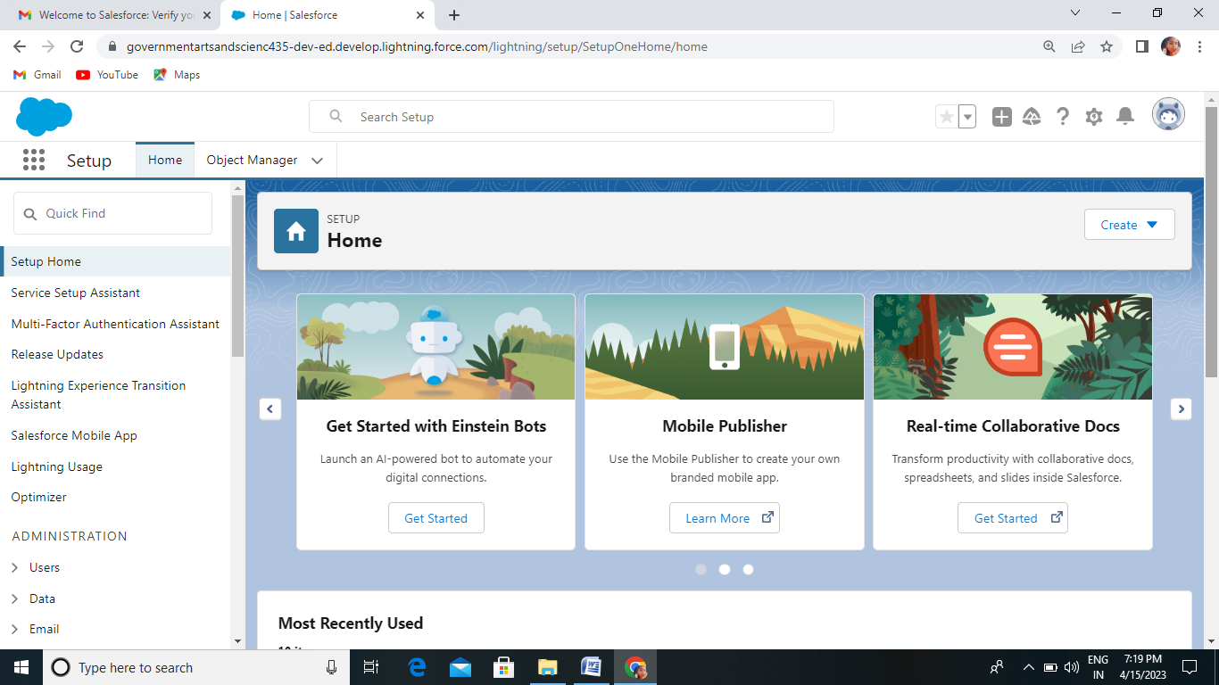

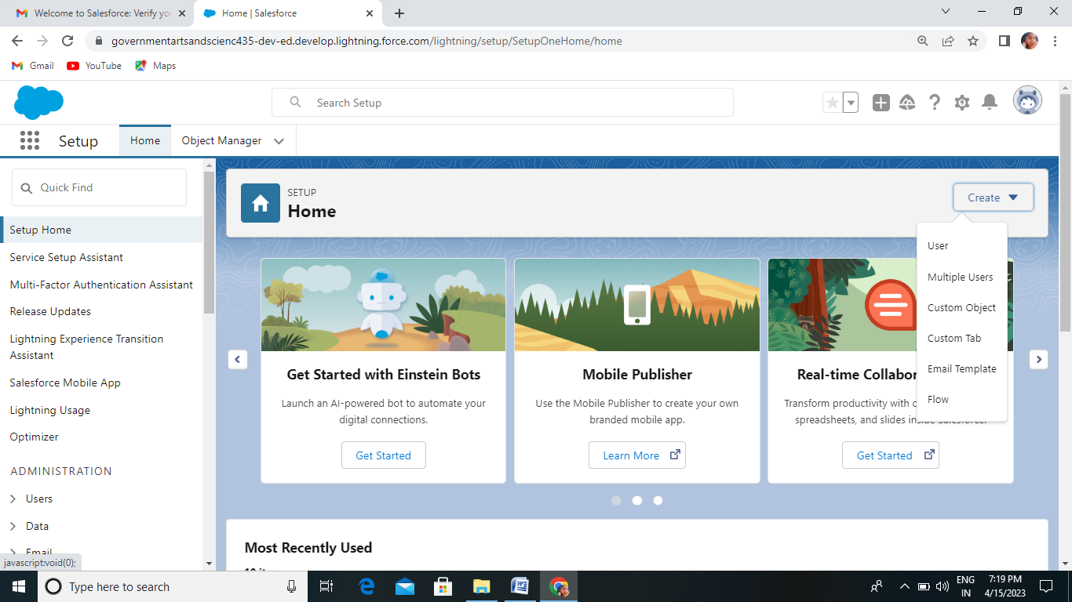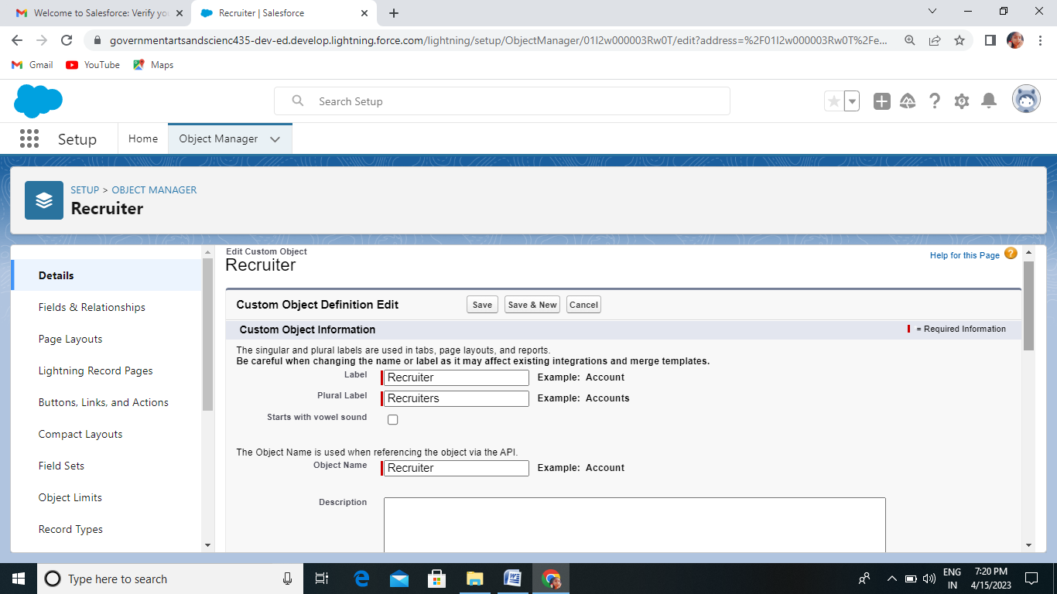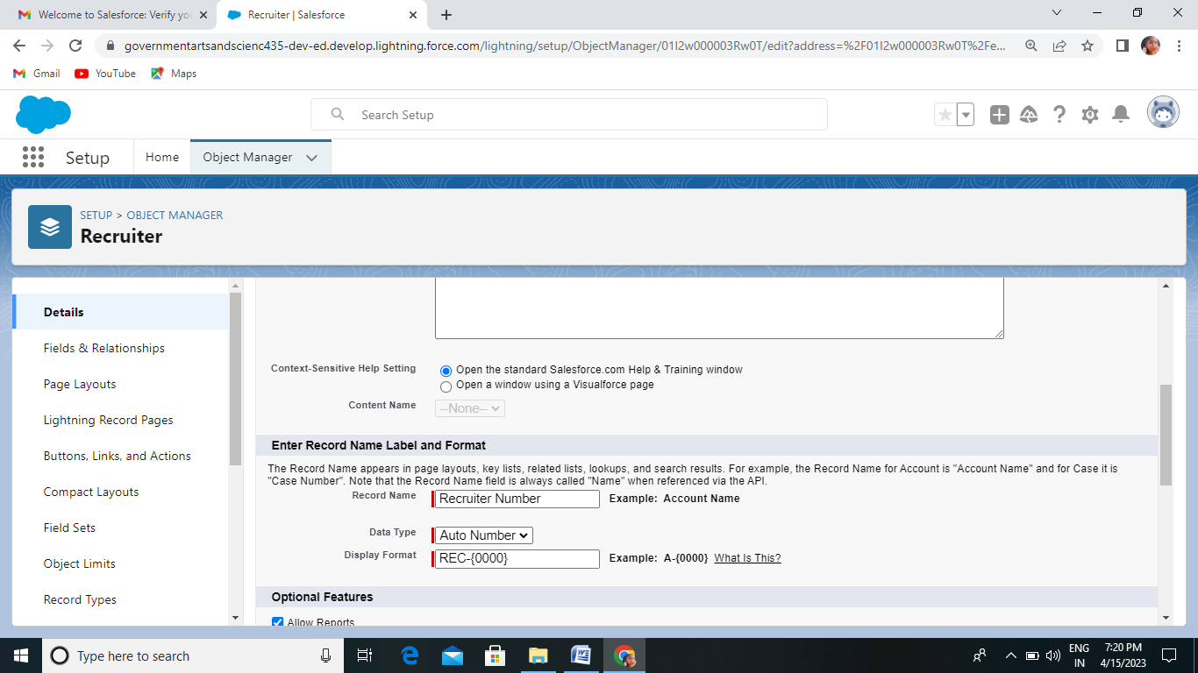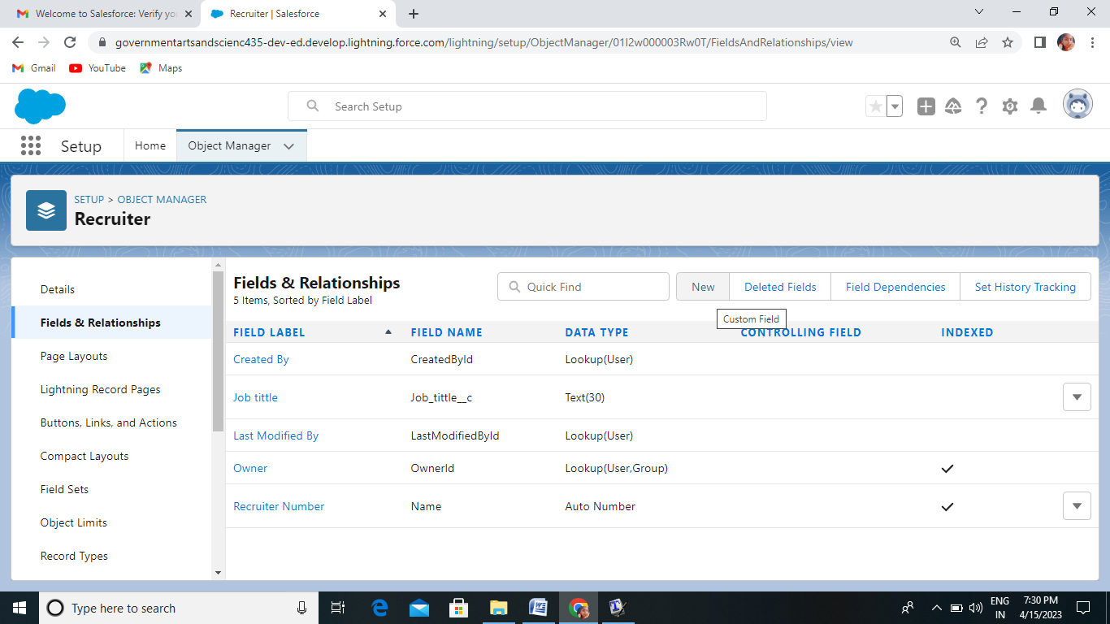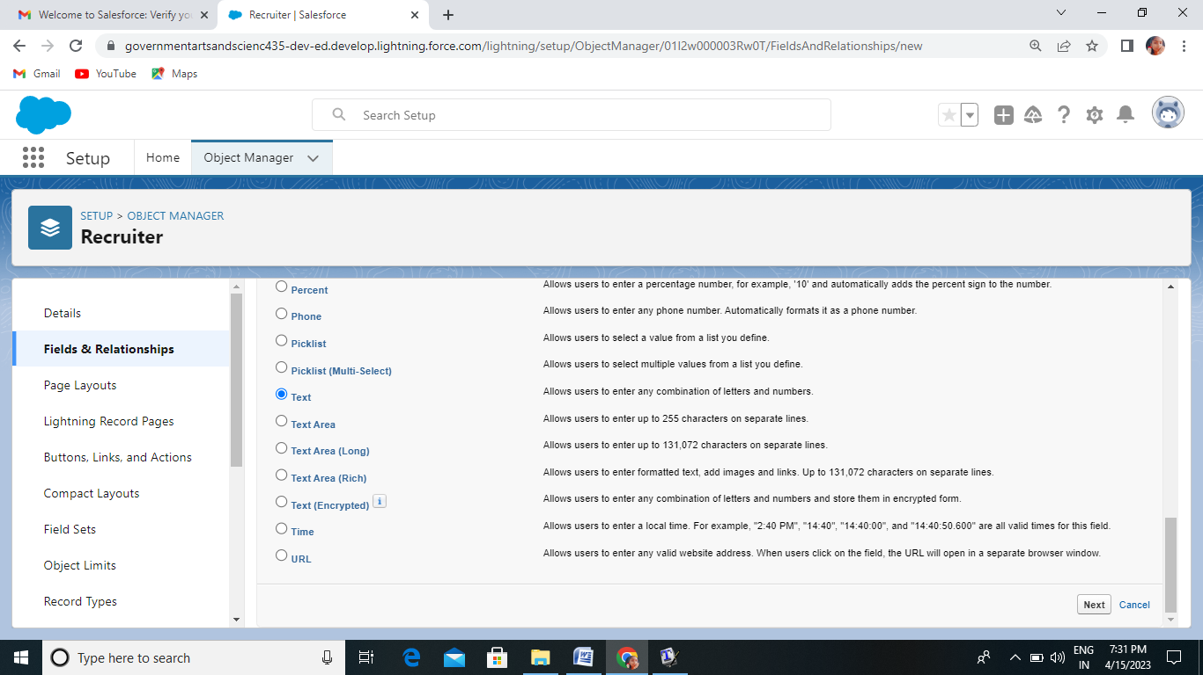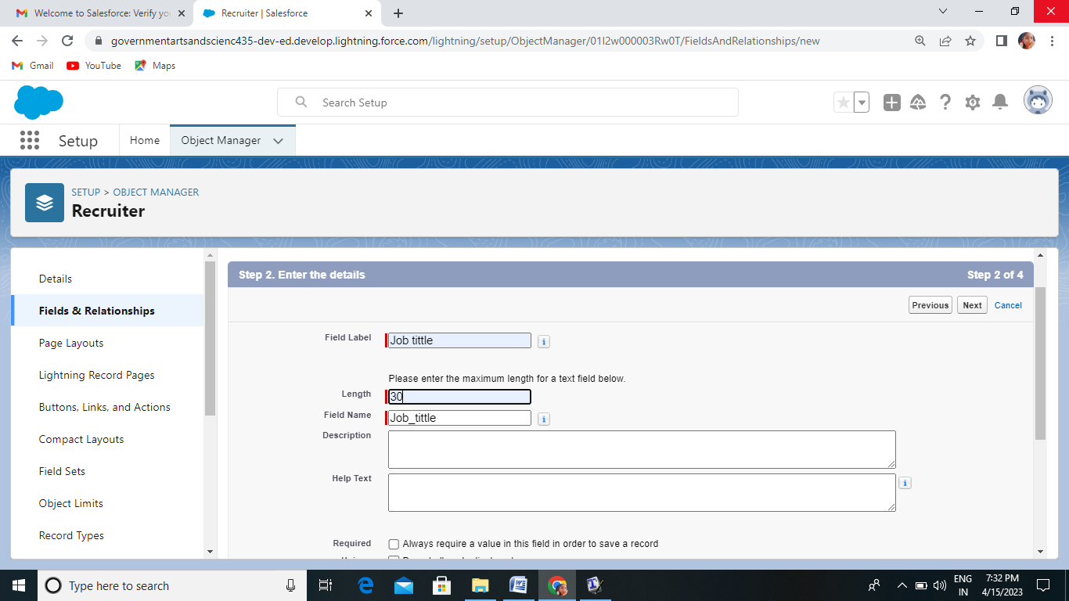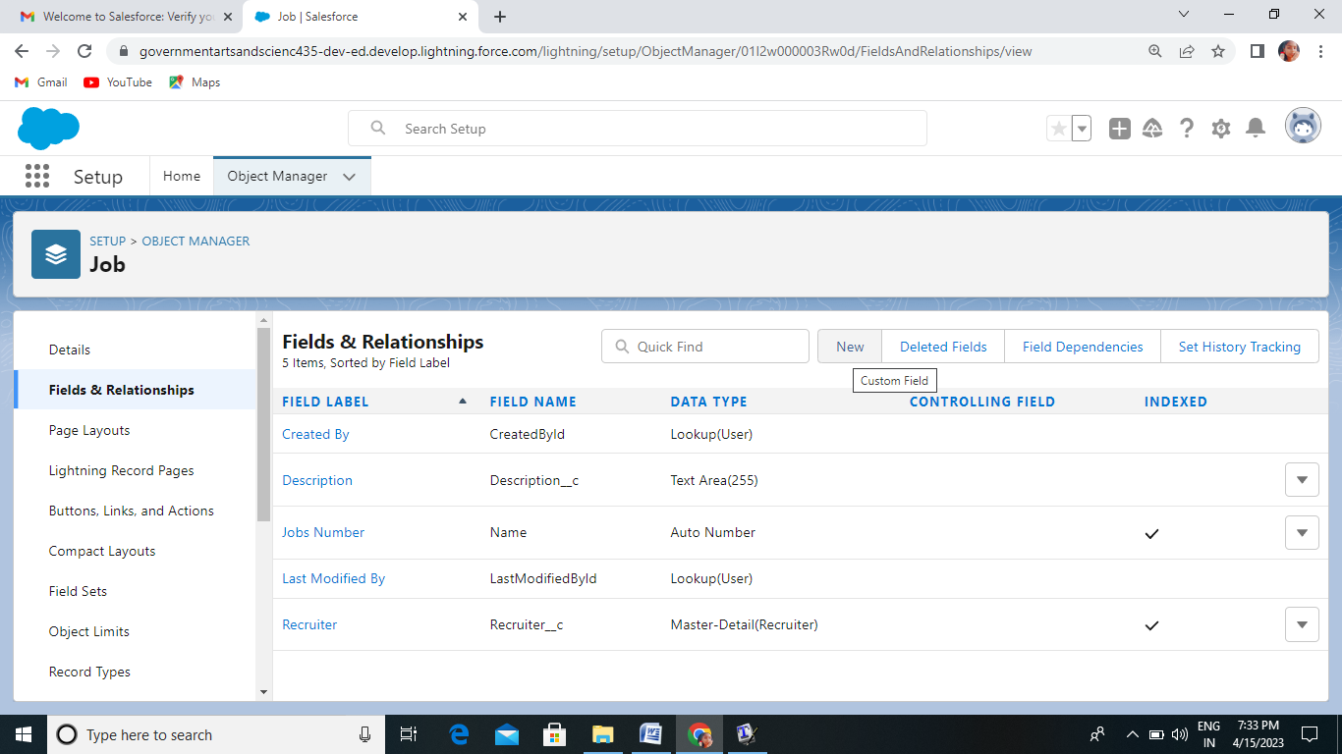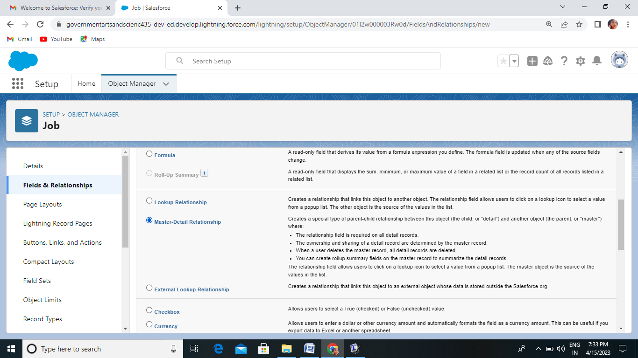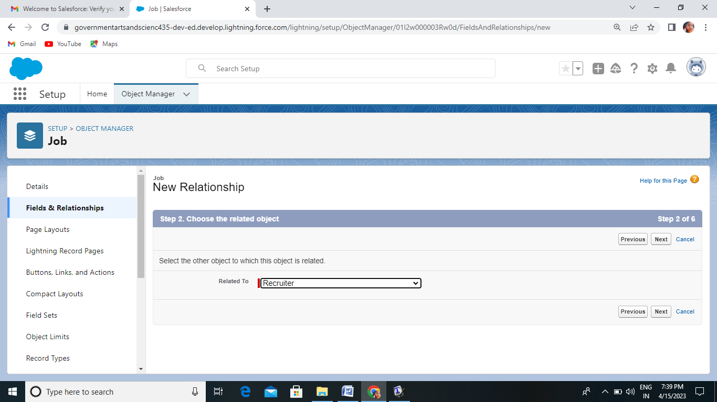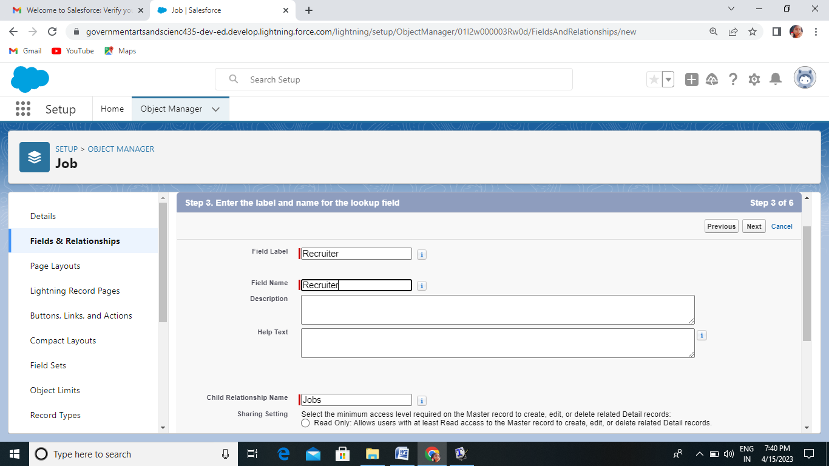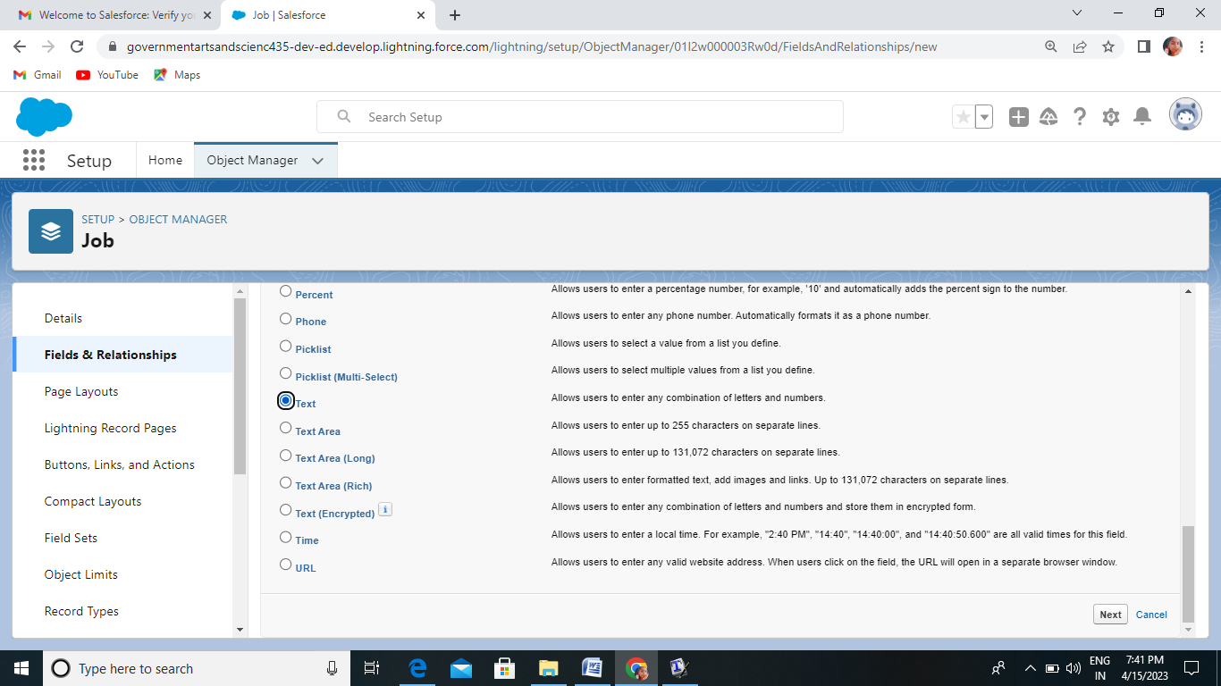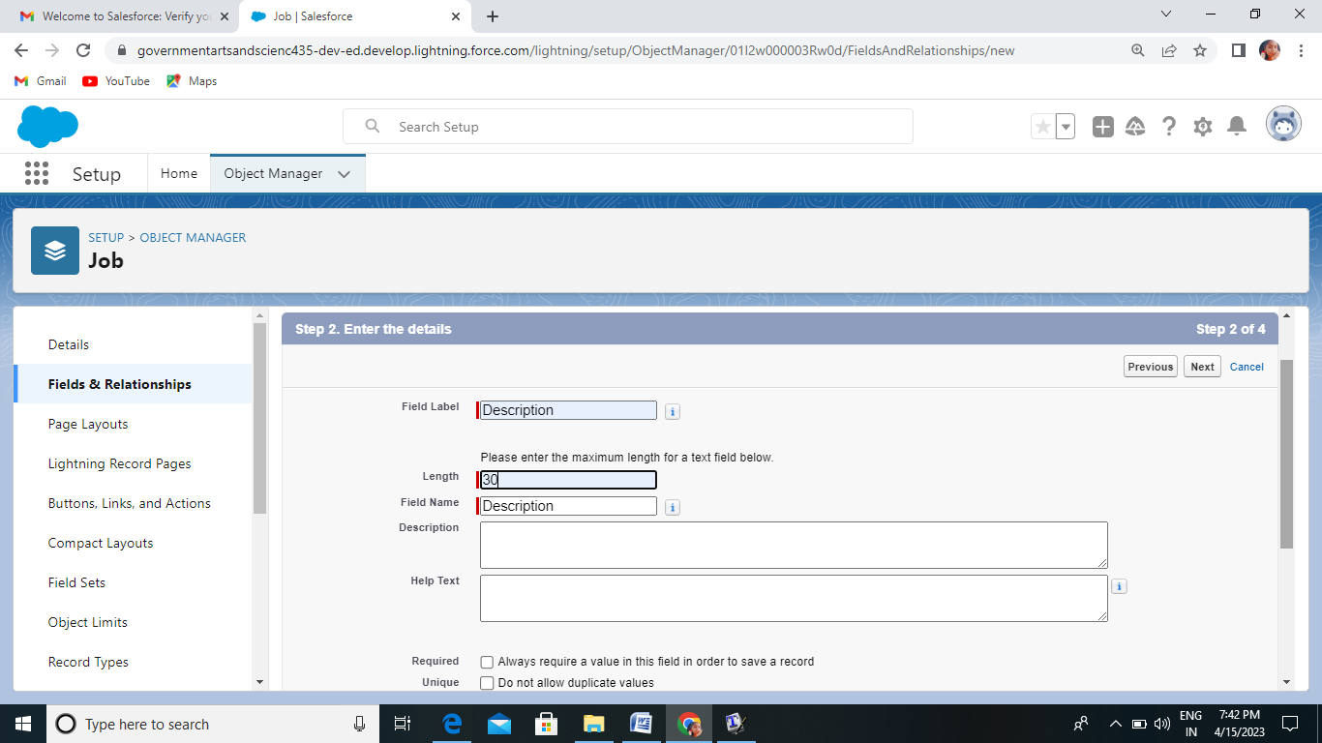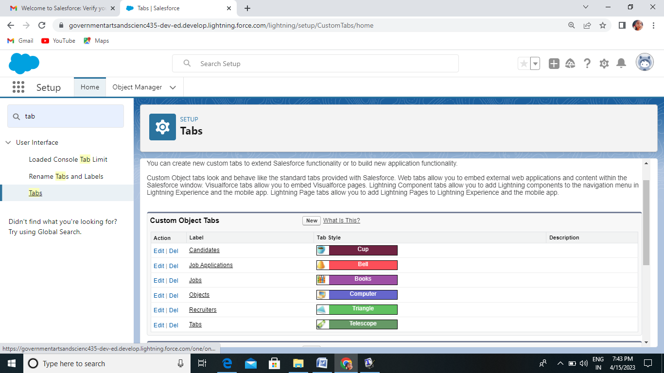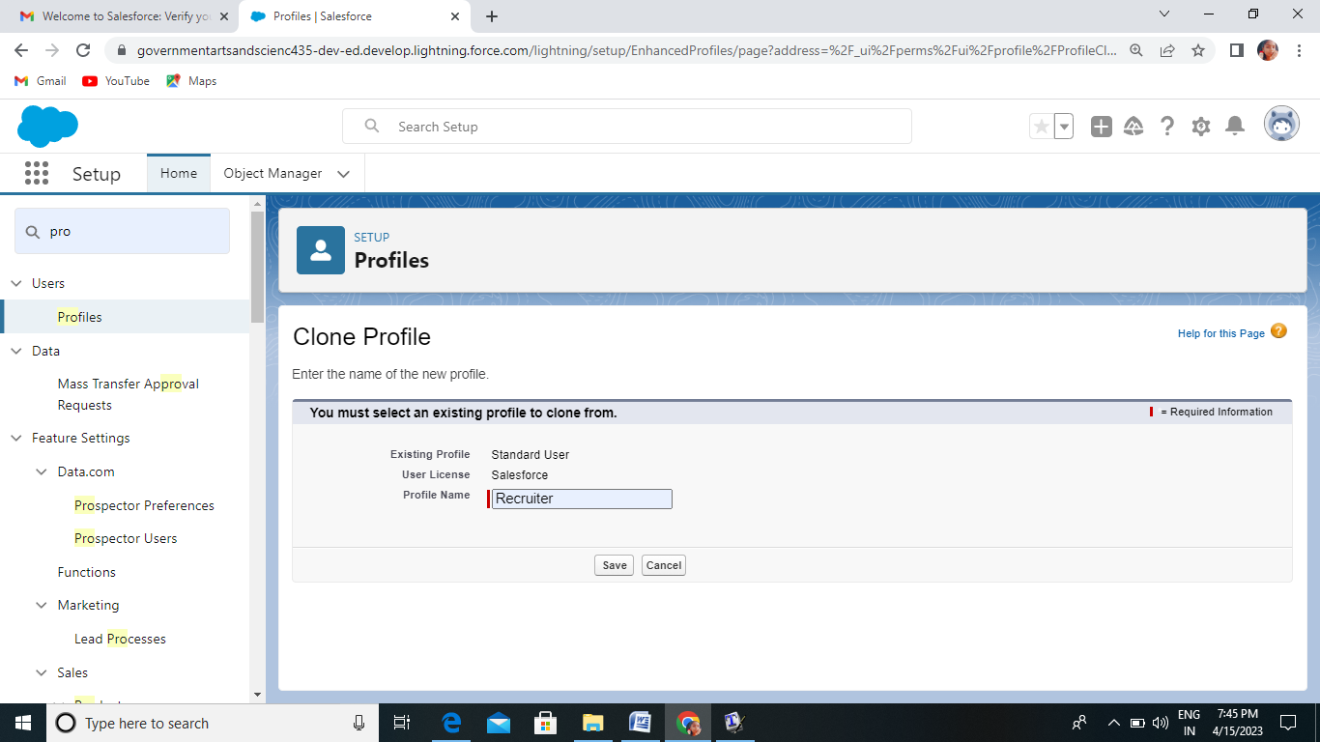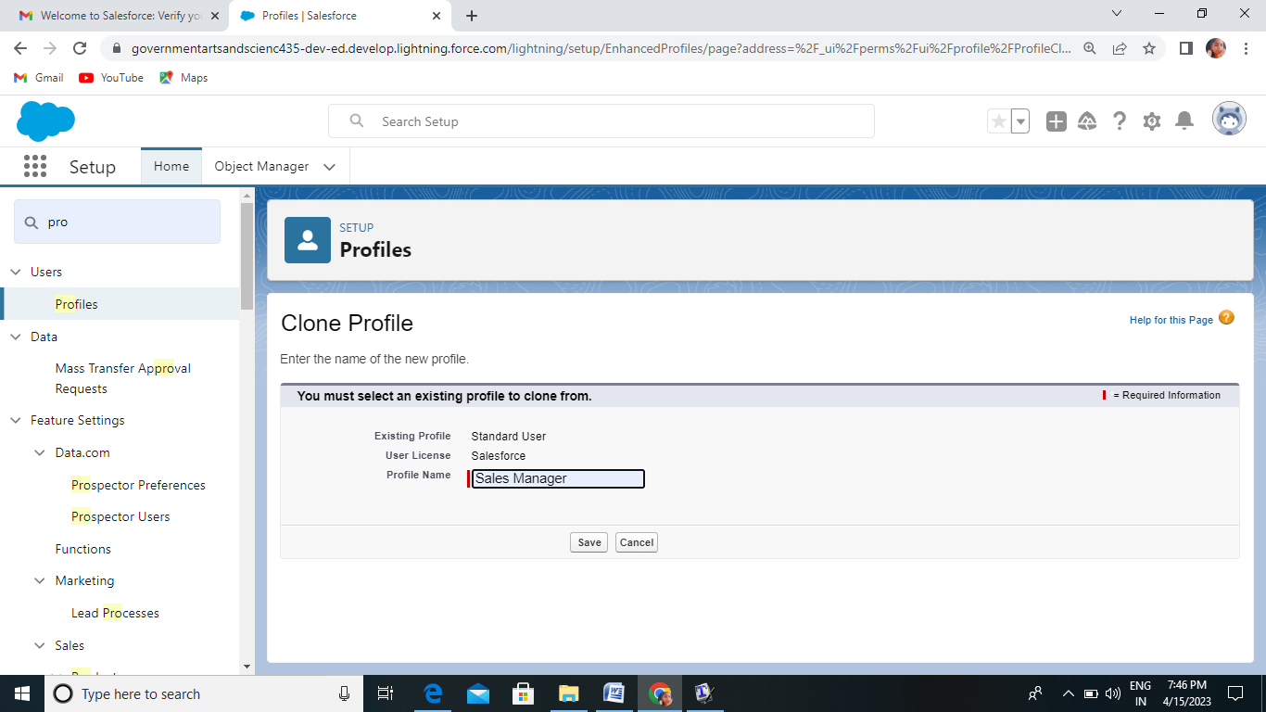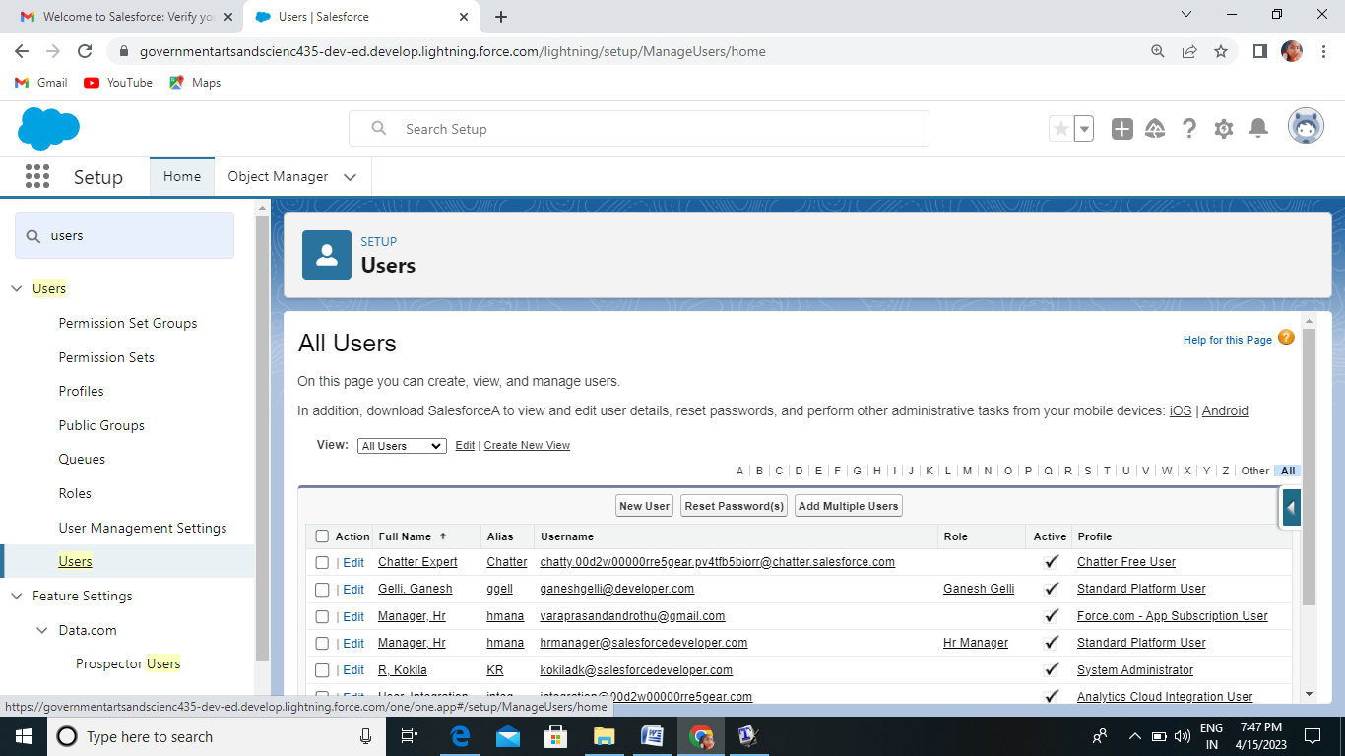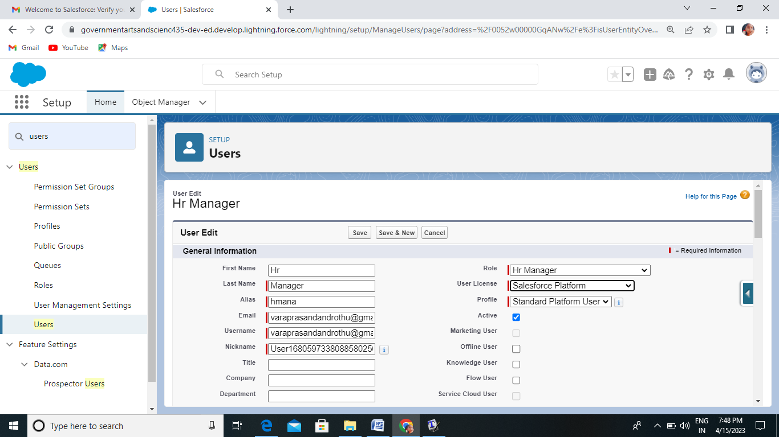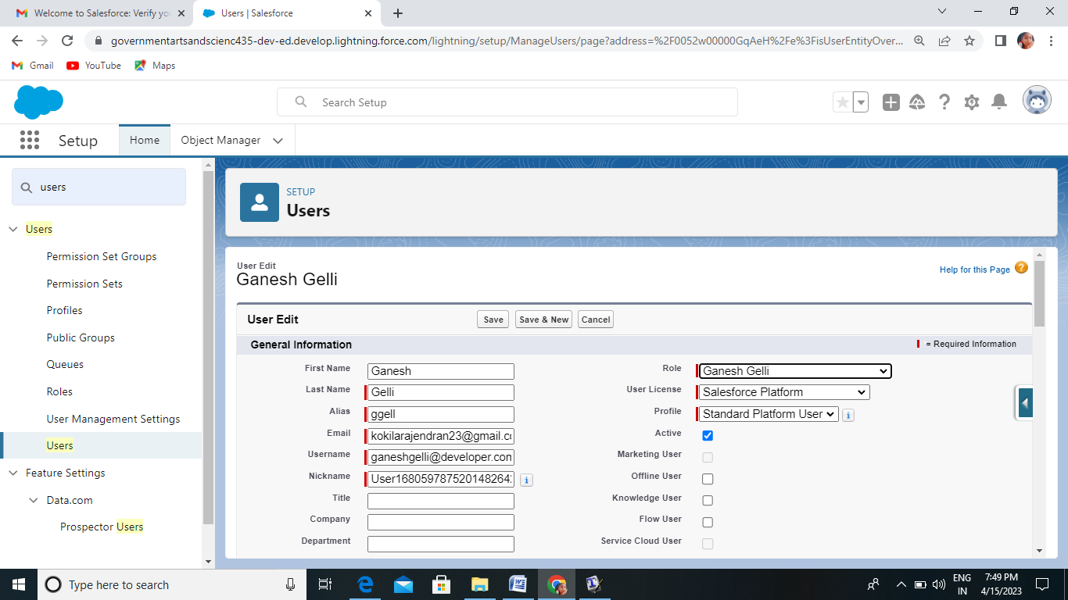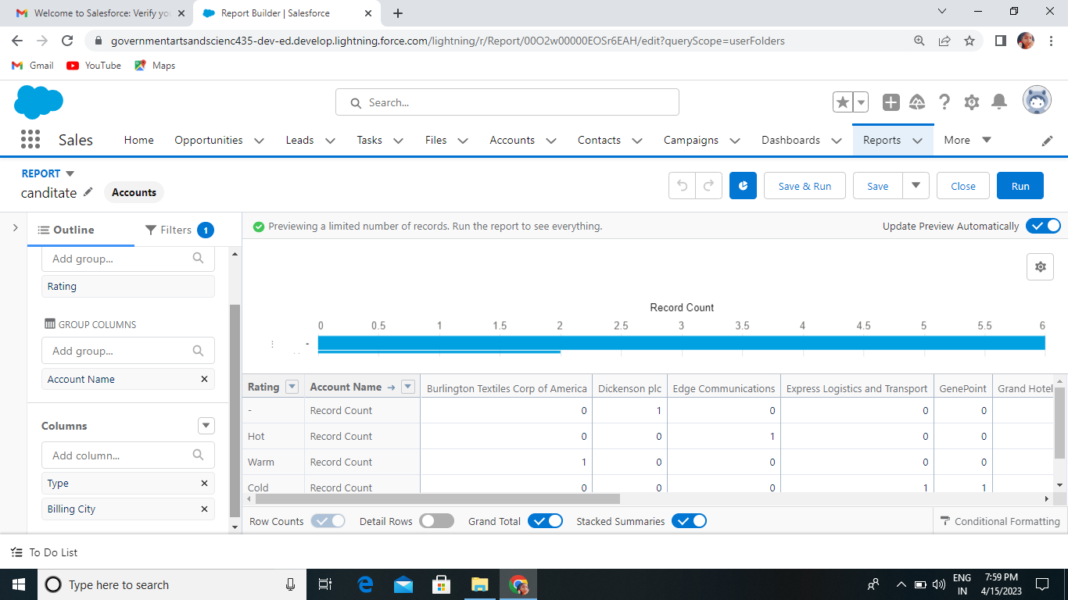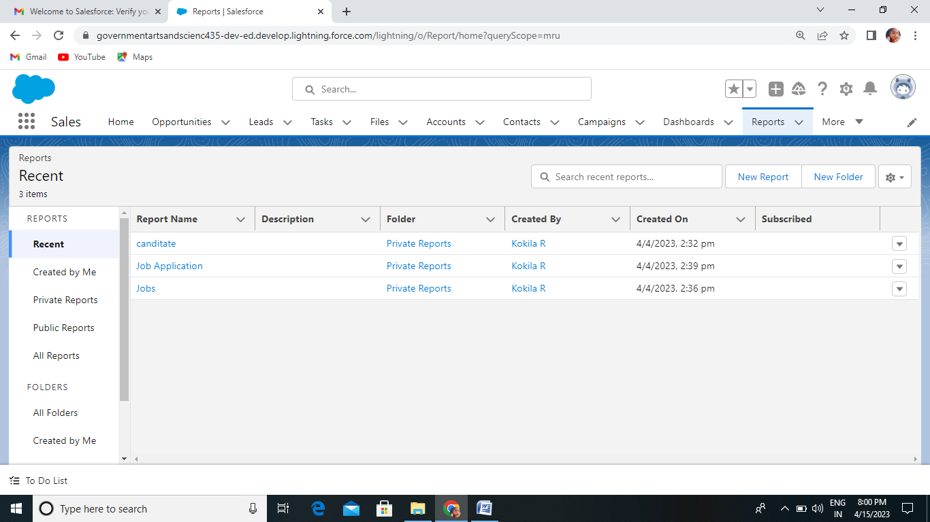

**4.Trailhead Profile Public URL:** 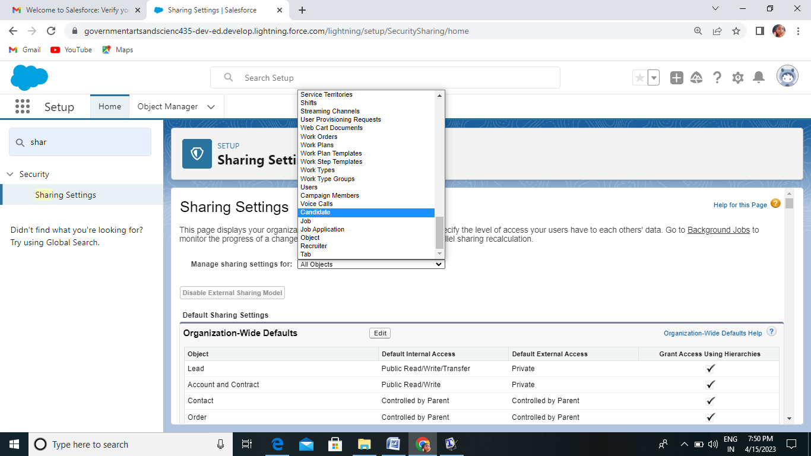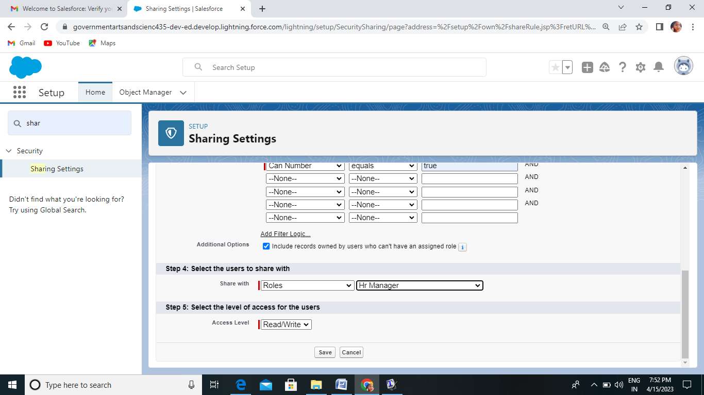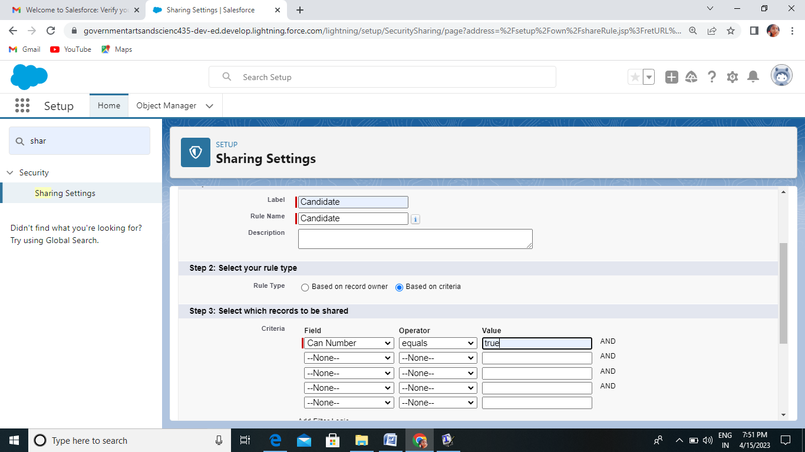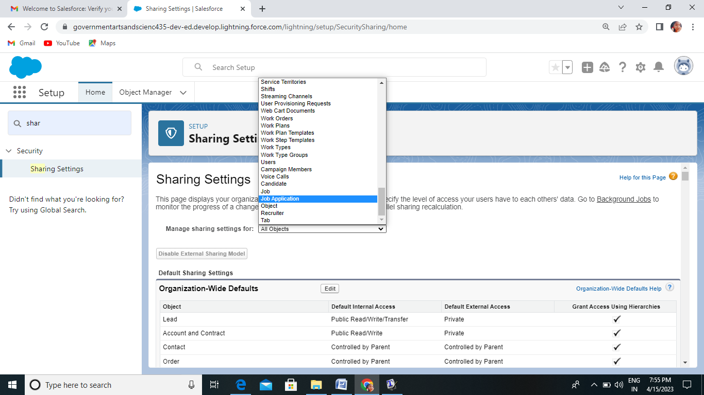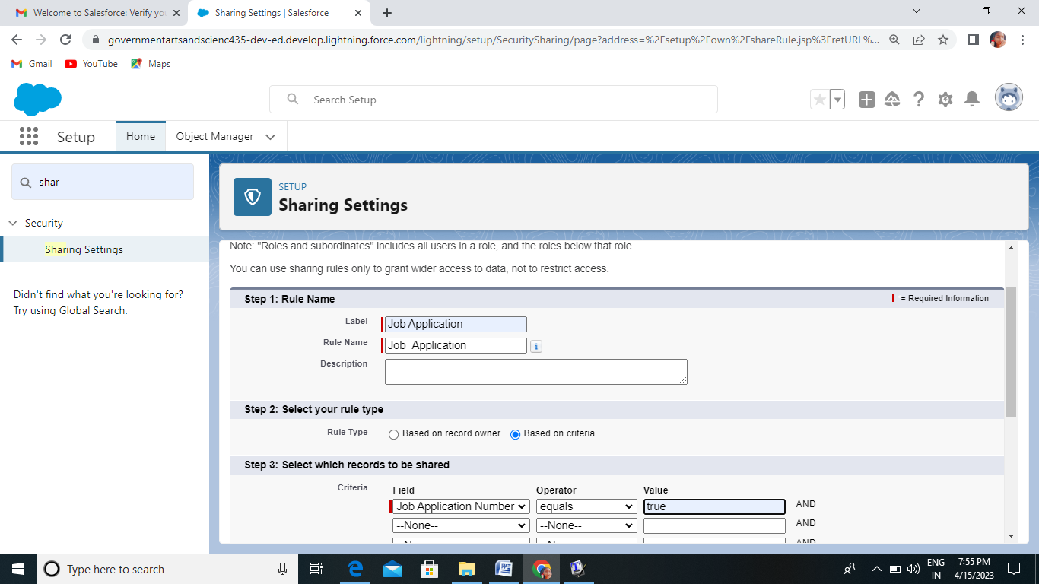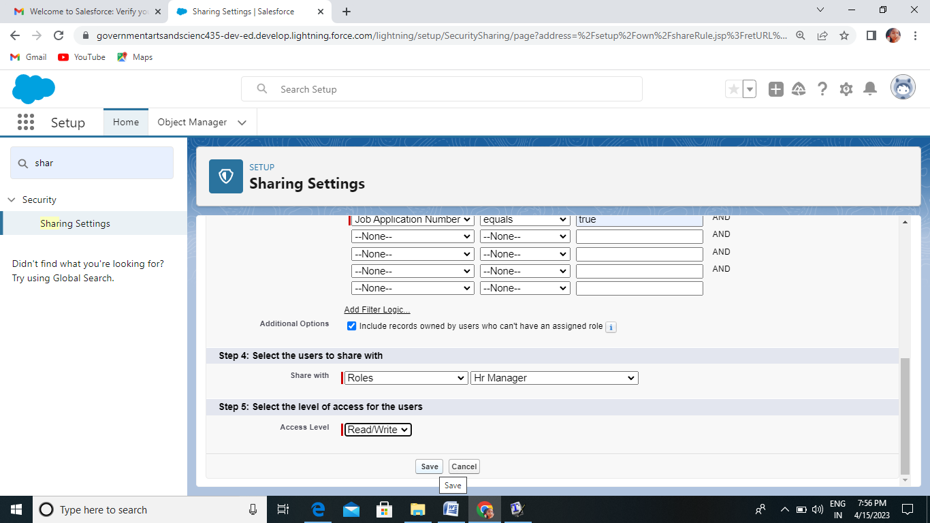

**Team Lead**: trailblazer.me/id/kavig20

**Team member** 1: trailblazer.me/id/kokir3

**Team member** 2 : trailblazer.me/id/kbala230

**Team member 3** : trailblazer.me/id/nramu20

**5.Advantages & Disadvantages**:

**Advantages**

1. saves time for value added work

2.flexible system for both employer&the agency

3. better overview of applications

4.easy job posting

5.improved cost_per_hire

6.improved quality of hire

7.improved inter_departmental communication

8.faster&Better D ecissions

9.Promotes Collaborative hiring

10.Entire Recruitment Cycle Speeds Up.

**Disadvantage**

1.A Disadvantage is missing qualified applicants due to wrong keyword selection.

2. Automatic elimination of resumes that software cannot recognize and interpret is another drawback .

3.An Applicant Tracking System Disadvantage is that they are open to manipulation.

**6.Applications**:

1.Easier communication among hiring manager.

2.Faster application screening

3.Reduced time spent on repetitive tasks

4.Improved net hiring score

5.Icreased candidate engagement

6.Better overview of application.

7.Easy job posting

8.Improved cost per hire

9.Improved quality of hire.

**7.Conclusion:**

Created a different models to track job profiles of the applicants by various recruiters.

**8.Future Scope:**

1.Perfect for high volume hiring.

2.Meets your exact requirements.

3. Effective cooperation

4.Higher productivity rates .